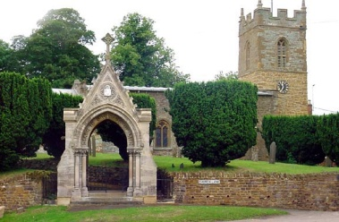
COLD ASHBY
ANNUAL PARISH ASSEMBLY
Wednesday 15th May 2019

The annual Cold Ashby Parish Assembly took place on Wednesday 15th May at 7.30 p.m. in the Village Hall.
Minutes
1. Election of chairman for the meeting (if the Parish Council chairman is present he will assume the chair automatically)
2. Apologies for absence
3. Minutes of the 2018 assembly - agreed
4. Welcome and introduction – the chairman explained the purpose and nature of the meeting.
5. Chairman’s report – the chairman of the parish council gave a brief report on the work and achievements of the council in 2018-19 and looked forward to activity in the coming year.
6. Cold Ashby Parish Environment Group (Capeg) – group to be discontinued.
7. Police and Community Support Officer – no firm conclusion
8. Street lighting. New lighting to be in place early 2020
9. Cemetery: changes agreed
10. Bus Service: no issues raised. No demand for a service on current lines.
11. Councillor Vacancy – no applicants at the meeting
12. Reports from District and County Councillors if present – not present
13. Open Forum – nothing raised

G Jones
CAPC clerk May 2019

